Slalom Occasion: W Hotel Verbier Debuts Slopeside at Swiss Alps Resort
December 3, 2013 1:03 PM
As Miami heats up with art and design happenings, writer Nancy Lazarus looks to Art Basel’s home country for a look at how W Hotels is schussing into the ski resort market.
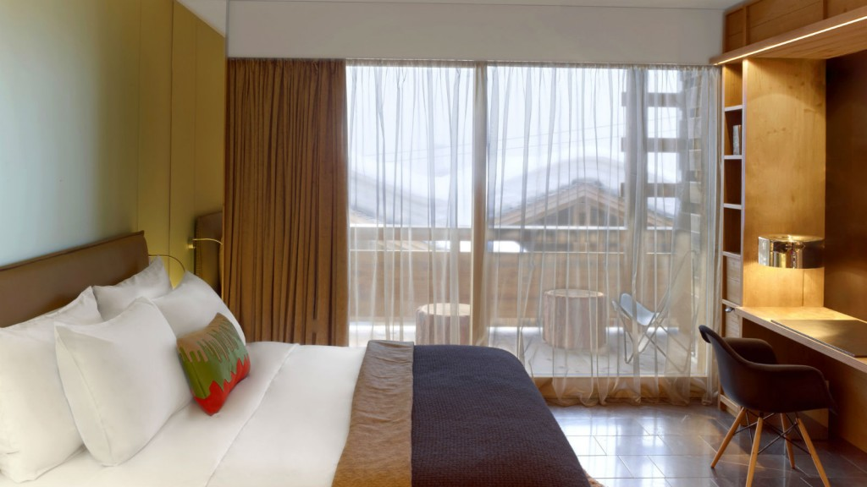
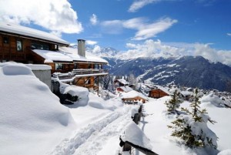Ski-in and ski-out access is de rigueur among alpine enthusiasts, particularly those who trek to the vast, steep slopes of Switzerland. The new W Verbier and The Residences at W Verbier offer just the ticket for avid downhillers and après-ski fans, with a prime location at the base of the mountain’s Medran gondola. Though to get there they may have to navigate past St. Bernards, either via the St. Bernard Express regional train or the Great St. Bernard Pass mountain road.
The W brand’s first Swiss property covers all terrains, with state-of-the-art lodgings, spa, restaurant, bars, and cafe. Much like Verbier’s four valleys ski area, the W resort is laid out in a series of four chalet-style wooden buildings interconnected by glass atria that feature climbing walls. W’s parent company, Starwood Hotels & Resorts, worked with Les Trios Rocs, the owners of the luxury development project.
“We wanted to bring the location to life in a W way,” said Ted Jacobs, W Hotels’ VP of global design, during a recent stateside press preview. The brand partnered with Dutch design agency Concrete Architectural Associates on the lodgings and with Spanish Michelin-star chef Sergi Arola on the cuisine.
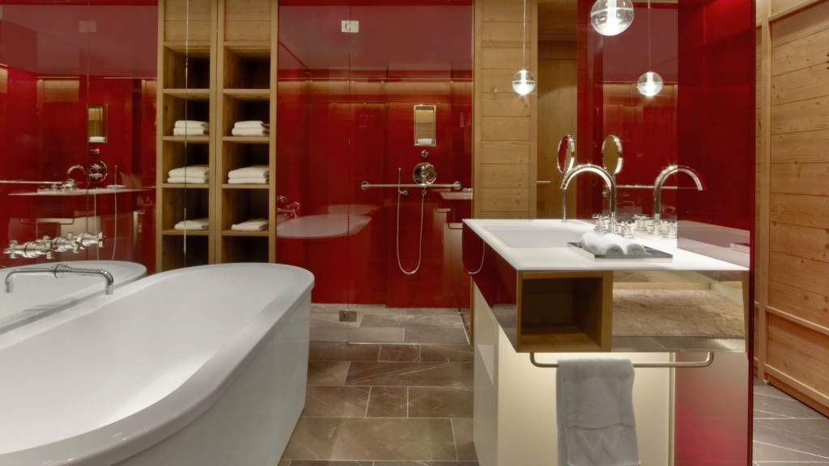
“We looked for local contexts,” Jacobs noted, so Swiss references figure prominently in the red and brown color scheme, indigenous materials and work of local craftsmen. The signature living room style lobby “is central to every W Hotel,” he said, since that’s where guests congregate. Modern rustic décor prevails, and floor-to-ceiling windows offer panoramic mountain views.
The concept of a Swiss army knife surrounded by different tools inspired the design of the 123 guest rooms, Jacobs explained. A singular piece of millwork wraps through the rooms, which are highlighted by fireplaces, balconies, and sleek, spacious bathrooms. The large suites are geared more towards après-ski revelers.
“The spa is very modern, not the clinical Swiss style,” said Jacobs. An open reception area leads to a “pampering zone” with treatment rooms, sauna, Jacuzzi, hammam and fitness center. A curve shaped indoor/outdoor pool has underwater lighting and a bar area. From one of the glass atriums, a staircase winds down to Carve, the main bar, that has a carved red cave-like entrance. For Verbier’s expert skiers, the “Stairway to Heaven” is a renowned off-piste trail.
W Verbier will also display global artwork: Jacobs said they’ve enlisted Australian tape graffiti artist Buff Dies to do installations. Dutch fashion photographer Marcel van der Vlugt is depicting seven local Verbier legends, such as an ice queen, Heidi, and of course, St. Bernards.
Writer Nancy Lazarus is a frequent contributor to UnBeige.

